**DevOps**

**Day 1**

**Date**: 17.03.2025

**Topics** **Covered**: Installation of Maven, Docker, Jenkins and Nginx in Windows.

**Jenkins**

**Running a Docker image from Jenkins:**

* Giving windows command and execute a docker image form Jenkins that exists in Docker
* Created a Freestyle project
* Configuring the details

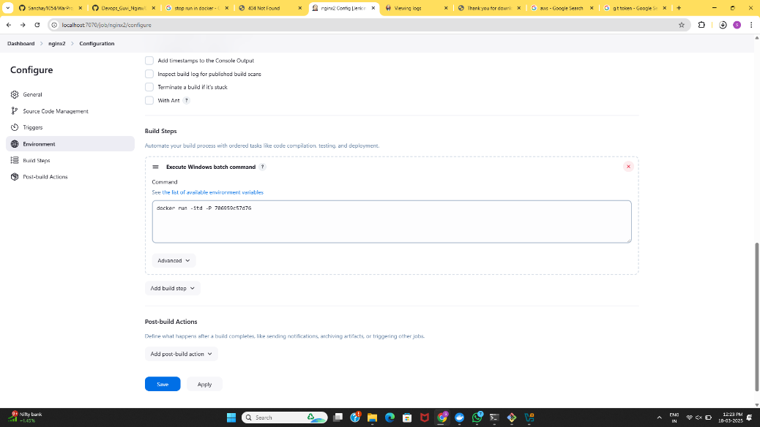

Freestyle

Building and Running the Project:

**Output**

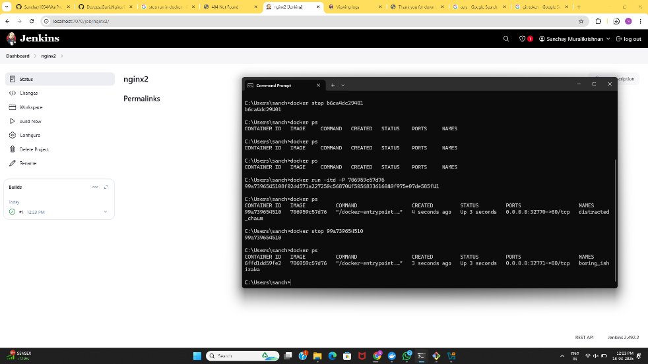

Build and run

**Uploading a local Docker Image to Docker Hub from Jenkins:**

Creating Docker image locally

* Creating a DockerFile for the maven war project
* Building it locally
* Checking the images
* Using bat windows script to push the image to Docker Hub
* Authenticated Docker Hub form Jenkins (script)

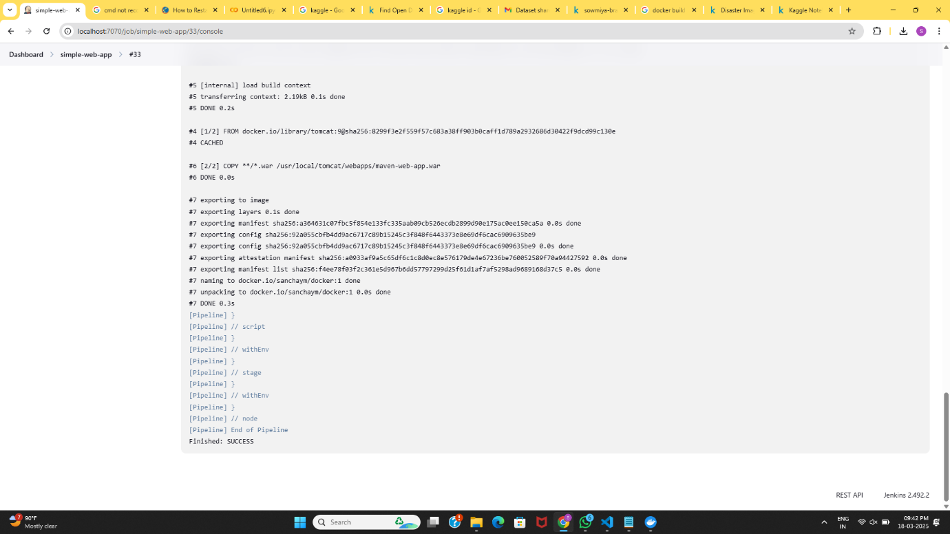

Authenticated Docker Hub

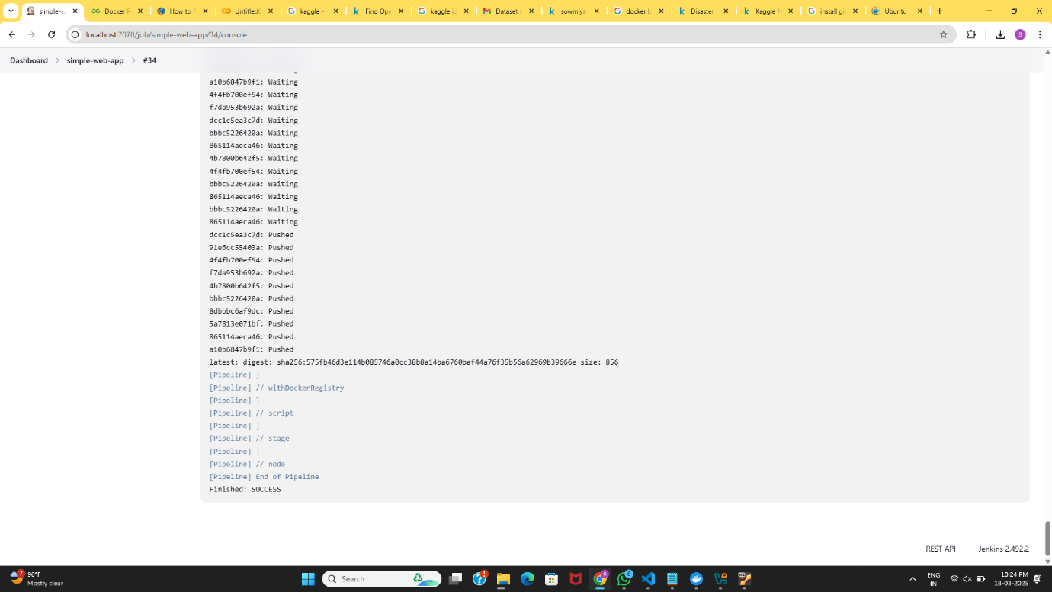

Image pushed

**Commands:**

pipeline {

agent any

tools {maven 'mvn'}

stages {

stage('scm') {

steps {

git 'https://github.com/Sanchay1054/WarProject.git'

}}

stage('build') {

steps {

bat "mvn clean"

bat "mvn install"

}}

stage('build to images') {

steps {

script{

bat 'docker build -t sanchaym/simplewebapp .'

}

}}

stage('push to hub') {

steps {

script{

withDockerRegistry(credentialsId: 'Docker', url: 'https://index.docker.io/v1/') {

bat 'docker push sanchaym/simplewebapp'

}}

}

}

}

}

**Output:**

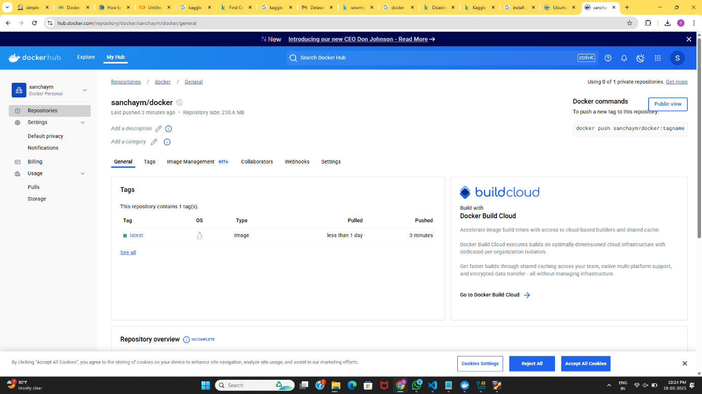

Image pushed to Docker Hub

**Nginx**

**Running Nginx local server**

* Installing Nginx
* Downloading Nginx from Docker
* Starting the server

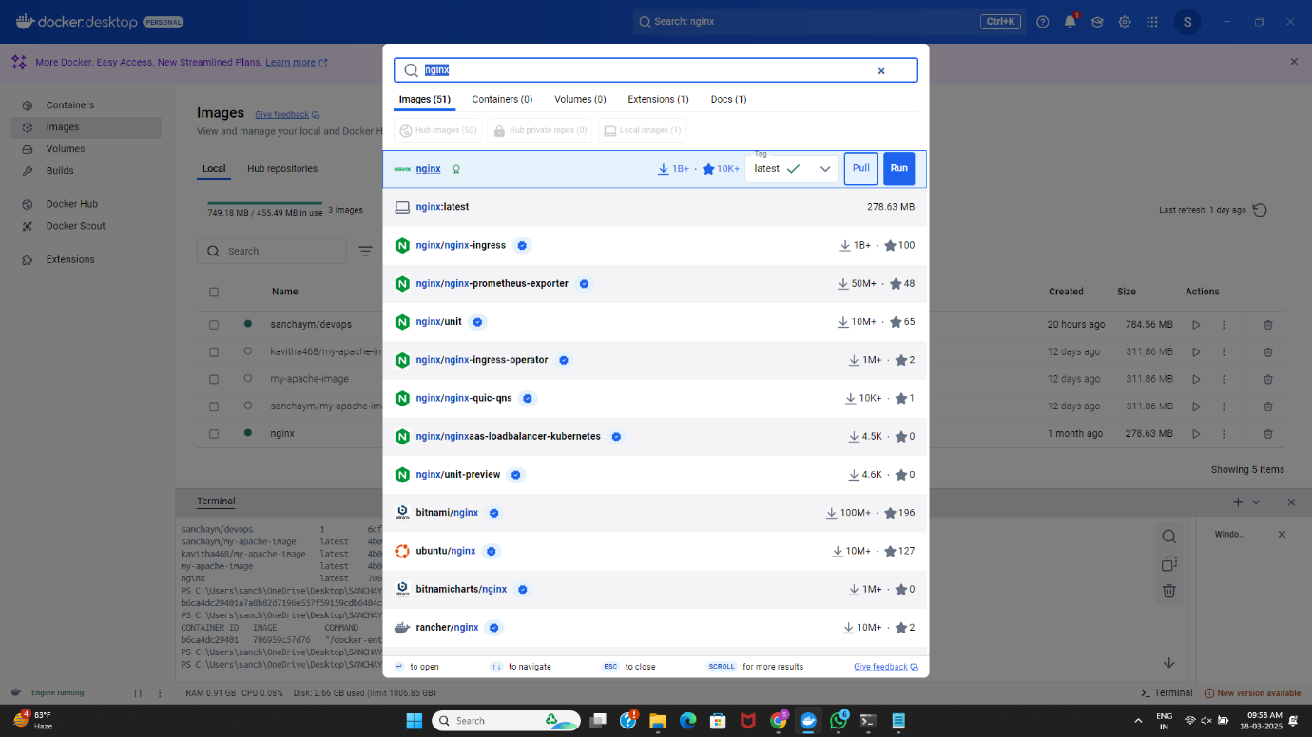

Installing Nginx image from Docker

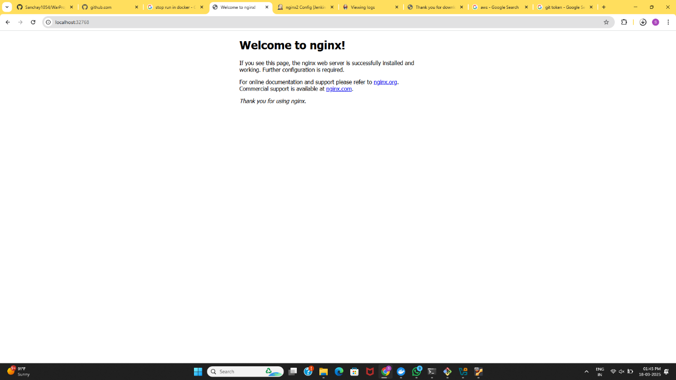

Starting Nginx server

* Running the war project from Nginx

**Output**

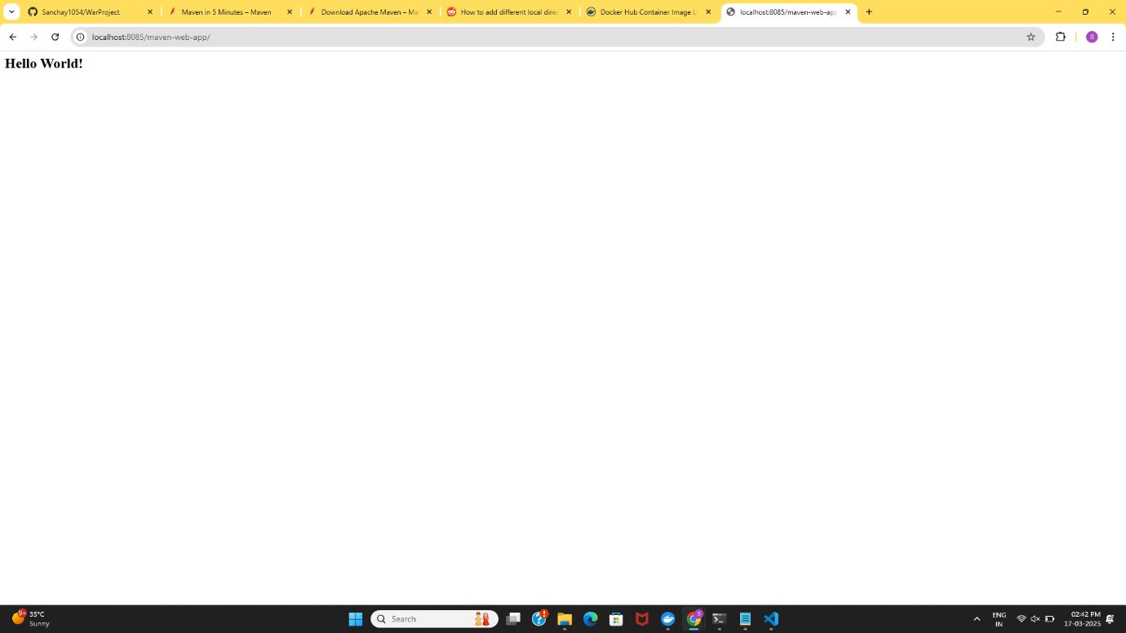

Output War Project

**Maven**

**Creating a maven project**

* Installation of maven locally
* Creating new maven war project
* Testing and it
* Validation and installation of packages